Relationship Between Social Media Usage and Church Attendance

Lissette Hernandez

ECON 43501: Charity and Voluntarism

**Abstract**

The impact of technology throughout the past 20 years has had dramatic effects on how people decide to engage with one another on personal and societal levels. These digital platforms, specifically social media, have formed into pathways and opportunities for people interact with facility without the need of in-person interactions. However, how does this increased engagement with social media platforms substitute or complement traditional forms of religious participation? This paper explores the relationship between social media usage and church attendance in the United States using data from the General Social Survey (GSS). The key variables used are “instagrm”, “facebook”, “snapchat”, “twitter”, “attend”, “age”, “income”, and “relig”. With an OLS regression framework, we find a statistically significant negative relationship between using these platforms and church attendance, with the stronger effects mostly seen in younger demographics. This highlights the interplay between virtual and traditional forms of religious engagement.

**Introduction**

As technology continues to evolve the usage of social media continues to increase. It’s human nature to want to feel connected and have a sense of community in a modern-day world, so ultimately this has transformed how individuals connect and engage. Social media is often studied from a social and psychological point of view, however less is known about its influence on traditional forms of communal participation such as religious attendance. This paper tests to explore how engagement with specific social platforms--Instagram, Snapchat, Twitter, and Facebook --are associated with how often people attend religious services in the United States.

To go forward with this observation, I use data from the General Social Survey (GSS) to test whether people who use social media are less likely to attend church. Two main regressions are used for this observation: the first regression focuses on regressing social media platform use (our independent variables) with church attendance (the dependent variable); the second regression keeps the same variables with the addition of control variables being age and income to account for potential confounding factors. Our preliminary results suggest that there is a negative association between social media platforms and church attendance, indicating that the four social media platforms we tested do not influence religious participation. However, looking into the control variables may offer insights into how religious institutions may need to adapt to tailor to specific groups and modern times. Through examining broader topics of religion and media platforms, I aim to add a perspective on the relationship between media platforms and traditional institutions.

**Background**

In prior research done, it has consistently been shown that every generation of adults is somewhat less religious than the generation that preceded it. This pattern continues with Generation Z demonstrating less attachment to religion than the millennial generation did (American Survey Center). With the increase presence of digital media, on one hand, we can argue that these platforms may substitute for in-person religious involvement by fulfilling social needs online. While on the other hand, they may also enhance religious involvement by fostering online community engagement and spreading religious content. The General Social Survey has tracked religious attendance in the US since the 1970s and incorporates engagement of the social media platforms we are examining correlates with religiosity participation. The relationship between social media use (x) and church attendance (y) could work if time spent on social platforms displaces time for spiritual worship or fulfills social needs digitally. However, it could fail if social media enhances religious participation through streaming services and ulterior exposure to religious content or community building.

**Data**

The General Social Survey (GSS) is a biannual survey that tracks demographic characteristics of U.S. adults. For this research study, the variable “attend” is the dependent variable that describes the frequency of attending religious services. While the independent variables, consist of “instagrm”, “snapchat”, “twitter”, and “facebook” all describing whether a person uses those specific platforms. The control variables “age” indicates the age category of a person, while “income” shows the yearly average income of an individual. I included all the missing values to see how they affect the overall results. Table 1 has descriptive statistics and showcases the means, standard deviations, and distribution of church attendance by social media platforms. This will essentially provide a foundational understanding of the data and show the basic relationship between each platform used and the religious participation. Table 2 shows how each platform and control variable affect our regression results on religious attendance. While figure 1 shows a distribution of social media usage based on religious denominations separated by social platform.

**Methods**

To estimate the relationship between social media usage and religious participation, we have to use regression models where the dependent variable (attend) is the frequency of church attendance. The first regression model is an Ordinary Least Squares (OLS) regression model that accounts for all the dependent and independent variables mentioned previously. While the second regression model is also OLS, but with the addition of control variables of age and income.

**Regression 1:**

y = b0 + b1*instagrm + b2*snapchat + b3*twitter + b4*facebook

**Regression 2:**

y = b0 + b1*instagrm + b2*snapchat + b3*twitter + b4*facebook + b5*age + b6*income + e

b0 = intercept; the expected value of attend when all social media usage is 0

b1,b2,b3,b4,b5 = coefficients for each social media; represents the effect of each on attend

e = error term; represents the variation in attend explained by the independent variables

Some potential challenges facing this regression are that on one hand time spent on social media may reduce religious attendance by replacing in-person participation. While on the other hand, social media can strengthen religiosity by having individuals stay involved in their church communities online. Though this entirely depends on the specific platform, such as Facebook having livestreaming while Snapchat does not, therefore having a higher usage result.

Moreover, omitted variable bias is also a concern given that, for example, individual personality traits like introversion and extroversion can alter church attendance and social media use. Table 2 column 2, contains the OLS regression outputs of church attendance on social media variables without any controls. This will help identify the unadjusted association between social media usage and church attendance. From our results we observe that the F-statistic is not statistically significant (p > 0.05), R-Squared only explains 0.1% of the variation in the dependent variable within the model, and all the media platforms have higher p-values than 0.05. Regression results indicate none of the platforms are statistically significant on attend. All the p-values are above 0.05, and the R-squared value is very low, suggesting that the model does not explain any variation in attendance.

Moreover, Table 2 column 3 shows the additional OLS regression with control variables such as age and income to show how estimates change with adjustments. Adjusting these characteristics allows us to better isolate the association between social media usage and church attendance. From these results we see there’s statistical significance at the 0.05 level. R-squared explains about 1.04% of the variance in attend in the model, only age has a statistically significant relationship with attendance, while all the other variables had no significance. Since it can be determined that older individuals tend to have higher attendance, I wanted to further test whether the relationship between social media use and religious attendance depends on the religious group someone belongs to by using the variable “relig.” I created “relig” to dummy variables or indicator variables for each religion and incorporated them into the second regression equation with “Catholic” being the reference group. Those results can be seen in image 3, where each social media platform displays how much each religion is affected. These graphs suggest social media’s influence on religious practice depends heavily on religious identity.

**Results**

In conclusion, from our first initial regression all the variables did not have a significant impact on religious attendance. While our second regression with control variables indicates that older individuals have a higher religious attendance than those who are younger. From our additional analysis testing to see how the different platforms impacted attendance across different religious groups it indicated that yes, social media impacts church attendance differently across religious groups especially on Facebook. Facebook appears to have a more negatively associated with attendance. Social media use might be associated with certain choices, but by itself it does not have an impact on church attendance when other factors are account for. This shows that media narratives claiming social media pulls people away from church are not actually supported by the data or that the effect is small and indirect.

**Table 1: Distribution of Social Media Platforms by Church Attendance**

|  |  |  |  |  |  |
| --- | --- | --- | --- | --- | --- |
| Attendance Type |  | Facebook | Instagram | Twitter | Snapchat |
|  | Mean | 1.26 | 1.74 | 1.82 | 1.78 |
| Never | Standard Dev. | .44 | .44 | .38 | .41 |
|  | Mean | 1.33 | 1.73 | 1.81 | 1.79 |
| Less than once a year | Standard Dev. | .47 | .49 | .39 | .40 |
|  | Mean | 1.21 | 1.63 | 1.81 | 1.76 |
| About once or twice | Standard Dev. | .41 | .48 | .39 | .42 |
|  | Mean | 1.24 | 1.63 | 1.78 | 1.71 |
| Several times a year | Standard Dev. | .43 | .48 | .41 | .45 |
|  | Mean | 1.21 | 1.65 | 1.83 | 1.70 |
| About once a month | Standard Dev. | .409 | .48 | .37 | .46 |
|  | Mean | 1.27 | 1.66 | 1.78 | 1.75 |
| 2-3 times a month | Standard Dev. | .45 | .47 | .42 | .44 |
|  | Mean | 1.26 | 1.67 | 1.82 | 1.77 |
| Nearly every week | Standard Dev. | .44 | .47 | .38 | .42 |
|  | Mean | 1.26 | 1.74 | 1.79 | 1.85 |
| Every week | Standard Dev. | .44 | .44 | .40 | .36 |
|  | Mean | 1.26 | 1.71 | 1.92 | 1.79 |
| Several times a week | Standard Dev. | .44 | .45 | .28 | .40 |
|  | Mean | 1.25 | 1.69 | 1.81 | 1.77 |
| Total | Standard Dev. | .43 | .46 | .38 | .42 |
|  | Observations | 1367 | 1367 | 1367 | 1367 |

|  |  |  |
| --- | --- | --- |
| Variable | Univariate OLS  (Dependent Variable = Church Attendance) | Multivariate OLS  (Dependent Variable = Attendance) |
| Facebook | -0.022  (0.175) | -0.069  (0.183) |
| Instagram | -0.136  (0.187) | -0.315  (0.196) |
| Twitter | 0.090  (0.203) | 0.031  (0.209) |
| Snapchat | 0.193  (0.202) | -0.092  (0.215) |
| Age |  | 0.019**  (0.005) |
| Income |  | -0.006  (0.035) |
| Constant | 2.894**  (0.442) | 3.064  (0.597) |
| **R-Square** | 0.001 | 0.0104 |
| **F-Statistic** | 0.86 | 0.0410** |
| **Observations** | 1367 | 1266 |
|  |  |  |

**Table 2: Results from univariate and multivariate regressions estimated by OLS**

Numbers in parentheses represent heteroskedasticity robust standard errors

**Significance at the 0.05 level

**Figure 1: Social Media Usage Based on Religious Denominations Separated by Social Platform**

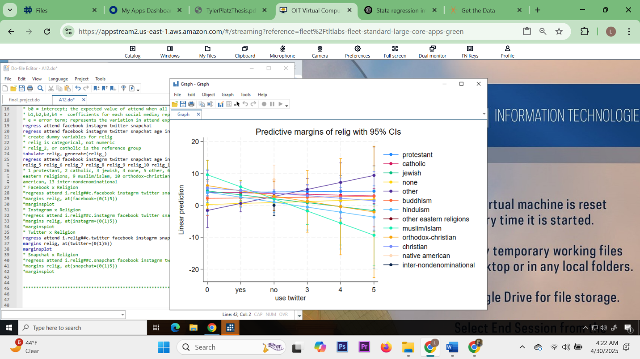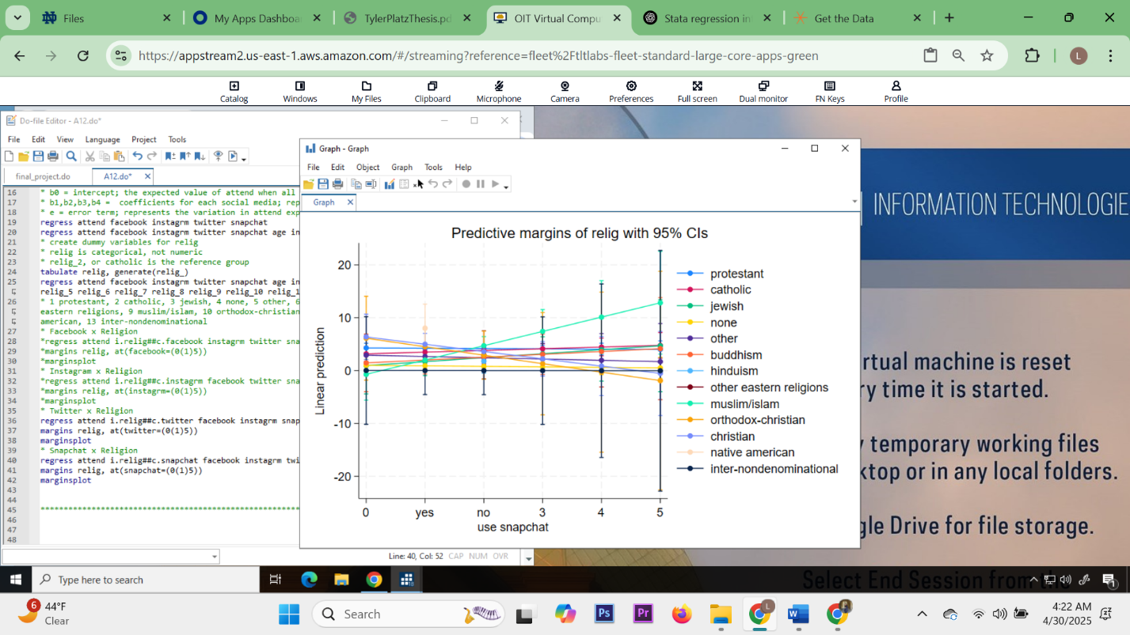

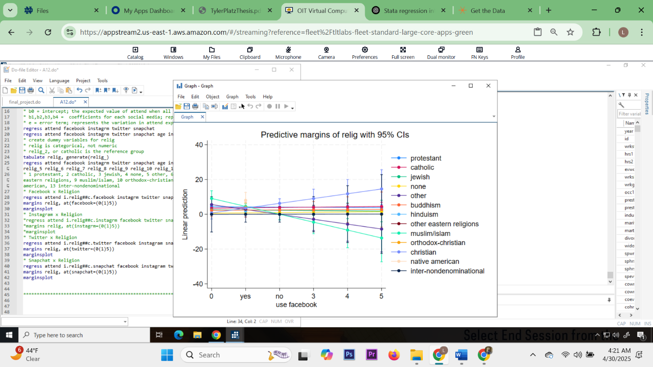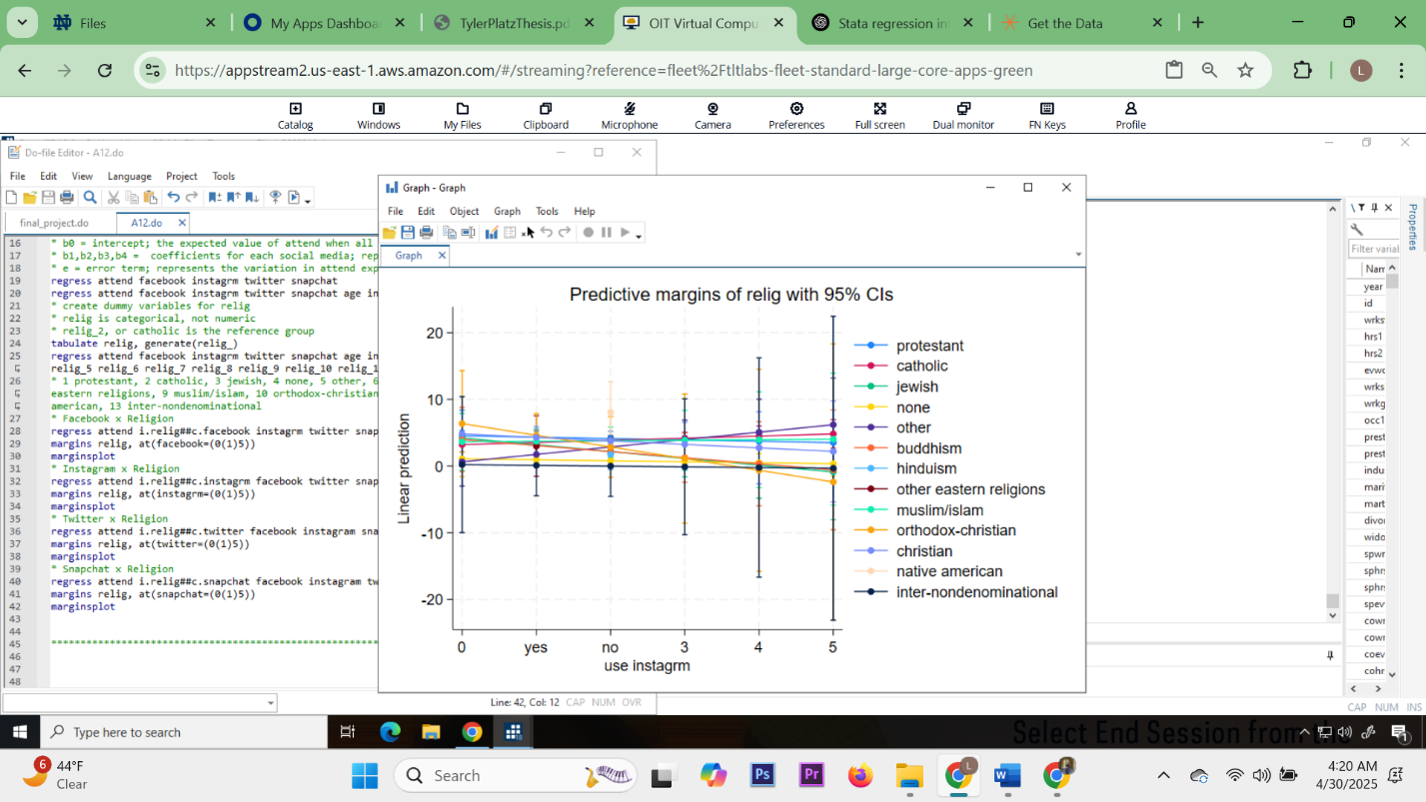

Twitter: Flat lines; little to no interaction effect between Twitter use and religion on attendance.

* None and Other religious groups show a negative trend, lower predicted attendance with more Twitter use.
* Confidence intervals are wide (error bars), especially at the ends, suggesting statistical uncertainty at extreme values
* For most religious groups Twitter use does not significantly change predicted church attendance. Among those with no religion, heavier twitter use might relate to lower attendance.

Snapchat: Flat lines or slightly upward; suggesting Snapchat use doesn't drastically reduce attendance.

* One exception: the “Jewish” group has a steeper upward trend, but with wide error bars, so it's not clearly significant
* Snapchat use appears to have minimal effect on attendance across religious groups, though non-religious people who use Snapchat more might be slightly less likely to attend.

Facebook:

* The “none”, “hinduism”, and “other eastern religions” groups show a strong downward trend. More Facebook use is associated with lower church attendance.
* Meanwhile, Christian, Catholic, and Orthodox-Christian groups remain flat or slightly positive.
* Facebook use is associated with lower church attendance, especially for non-traditional religious groups or those with no religion. The interaction effect is more evident here than in the other platforms.

Instagram: Flat lines or slightly downward.

* non-religious and Muslims show decreasing attendance with higher Instagram use.
* Other lines stay constant.
* Instagram use is mildly associated with lower attendance for a few groups (e.g., Muslims, None), but overall effect sizes are small.

Sources:

<https://www.americansurveycenter.org/research/generation-z-future-of-faith/>